Teaching of summary Writing

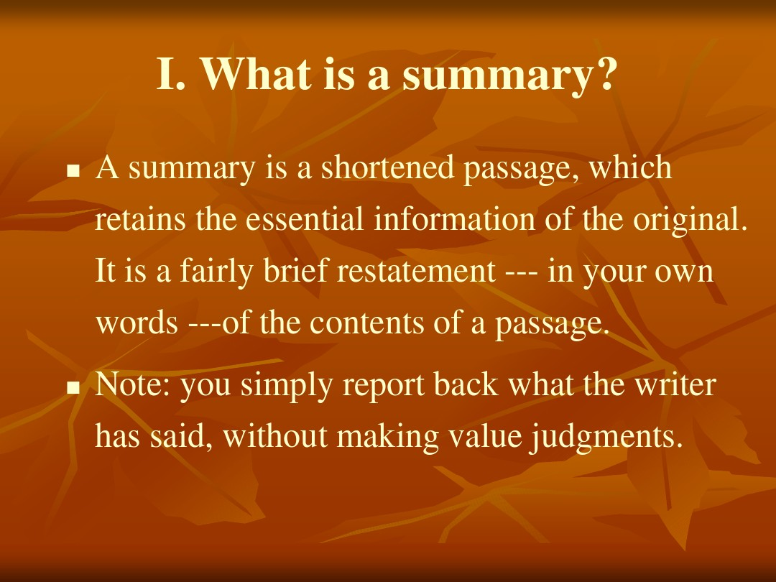

SUMMARY WRITING  

Definition and characteristics 

Steps in writing a summary 

How to write a summary 

Writing Practice

1.  What Is Summary?   

A summary is a shortened passage, which retains the essential information of the  original. It is a fairly brief restatement --- in your own words --- of the contents of a passage.   

Note: You simply report back what the writer has said, without making value  judgments.

2.  Characteristics of a good summary  

A. Briefness

B. Omit unnecessary details like examples, explanations and other unimportant information. (length: 1/4-1/3 of original text) 

C. Completeness   to include all the main and supporting points delivered in your own words in a condensed manner 

D. Coherence  rather than an outline listed as key words and phrase, a summary is a paragraph with  necessary transitions and function structures to make it flow.   E. Objectivity   to contain only the ideas or information of the original. Do not include your own ideas or emotions on the topic.

F. Some Useful Expressions of Transition: On one hand,…….On the other hand,……  One reason is ……Another  reason is ……Still another  reason is ……The final  reason is …… To begin with, ……What‟s more,……In addition,……Finally,…… In short,   From what is mentioned above,  we can come to the conclusion that ….    3.  Steps in Writing a Summary   Read the article

1). Divide the article into sections of ideas. Each section deals with one aspect of the central theme.

2). Label (classify) each section with a general phrase that captures the subject matter of the section.

3). Highlight or underline the main idea and key points Topic:     _________  Outlines: 1. ________a….. b….. c. ….           2. ________3. ________  

Begin with a proper citation of the title, author, source, date of publication  and the main idea of the article summarized.  

Write according to your outlines.  

Use transitions for a smooth and logical flow of ideas. 

Compress supporting details   1). Omit the details 2). Reduce the examples 3). Simplify the descriptions 4). Eliminate all repetitions  5). Compress wordy sentences and change clauses or sentences to phrases and  phrases to words.  6). Use general words instead of specific words 7). Use the shortest possible transitions 8). Avoid figurative (比喻的) language  9). Put the main points of a dialogue in indirect speech  Beginning a Summary  

Begin your summary with 1. The author‟s name  2. The article‟s or chapter‟s name  3. The author‟s thesis statement--a general overview (survey概述) of the article

The Opening Sentence:  e.g.  In the feature (特写；专题) article "Four Kinds of Reading," the author, Donald Hall, explains his opinion about different types of reading.

The Body：  First of all, the author describes…………      He then points out that……       In addition, the author talks about …..      Finally, the author suggests…………….     Some other introductory phrases   1.  (The author) states in (this article) that... 2.  (The author, in (this article) shows that... 3.  In (this article), (the author) writes that... 4.  As (the author) says in (this article), ... 5.  The main idea of (the author's article) is  6. The author believes (holds; maintains; claims; argues; points out; suggests;

议论文：

A good story encourages us to turn the next page and read more. We want to find out what happens next and what the main characters do and what they say to each other. We may feel excited, sad, afraid, angry or really happy. This is because the experience of reading or listening to a story is much more likely to make us 'feel' that we are part of the story, too. Just like in our 'real' lives, we might love or hate different characters in the story. Perhaps we recognize ourselves or others in some of them. Perhaps we have similar problems.

Because of this natural empathy with the characters, our brains process the reading of stories differently from the way we read factual information. Our brains don't always recognize the difference between an imagined situation and a real one so the characters become 'alive' to us. What they say and do is therefore more meaningful. This is why the words and structures that relate a story's events, descriptions and conversations are processed in this deeper way.

In fact, cultures all around the world have always used storytelling to pass knowledge from one generation to another. Our ancestors understood very well that this was the best way to make sure our histories and information about how to relate to others and to our world was not only understood, but remembered too.   Encouraging your child to read or listen to stories should therefore help them to learn a second language in a way that is not only fun, but memorable.

Possible Version:  An interesting story motivates/inspires us to read continuously, for it reflects our real lives. Ignoring the unreal factors, we usually feel empathy with the characters and think a lot about the words and structures related to the story. People all over the world have employed/ used storytelling to obtain knowledge and make children’s language learning meaningful and impressive.